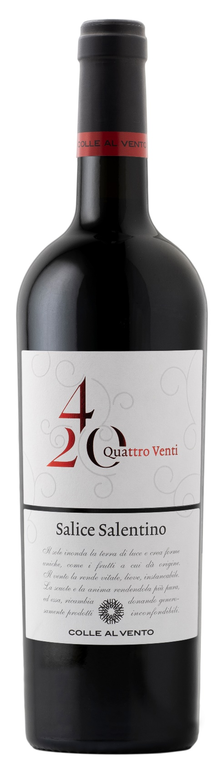
SALICE SALENTINO DOP – 4/20

Grape: Negroamaro, Malvasia Nera
Alc. Vol.%: 13,5
Vintage: 2025
Residual sugar g/l: 6,0
Total acidity g/l: 5,5
Region: Apulia
Production zone: Vineyards in the area of Salice Salentino and San Donaci (Lecce, Brindisi)
Capacity: 750ml

CHARACTERISTICS

Vinification: After a soft pressure and the separation of grape-stalk, the grapes are submitted to peel maceration of 8-10 days. The fermentation takes place at a controlled temperature
Aging: Aged in steel tanks for at least 8 months
Yield per ha: 12000kg
Colour: Intense red with garnet reflections
Bouquet: Interesting fruity aromas of plum and blackberry with evident notes of spices
Flavour: Strong, full bodied but also balanced and warm

SERVING SUGGESTIONS

Suitable for roast, game and spicy cheese.
Serving temperature 18 °C
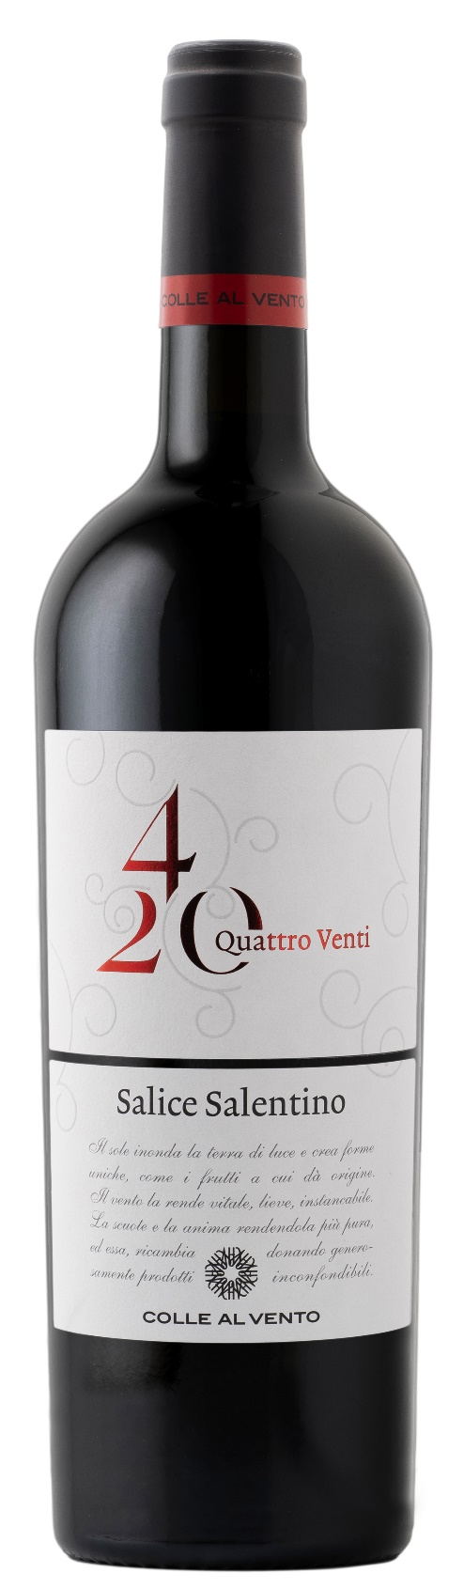
TECHNICAL INFORMATION / PALLETIZING

Size 750ml:
Article Nr. V03008A
GTIN-13 bottle 8017868004721
GTIN-13 carton 8017868003410
Closure Cork
Bottles / carton 6 bottles
Pallet size 80x120cm
Cartons/layer 21
Cartons/pallet 105
Kg/carton 7,8
Kg/pallet 840

Contains sulphites
GMO Free
Revisione 01. 14.05.2026

